Early Years Foundation Stage Policy

Last Reviewed : September 2026
Next Review Date : September 2028



Early Years Foundation Stage Policy
St John’s Primary School

Contents

1. Introduction
2. Our Mission and Vision
3. Aims and principles of EYFS
4. A Unique Child
5. Positive Relationships—Parents as Partners & Staff
6. Enabling Environments
7. Learning and Developing
8. Characteristics of Effective Learning
9. Planning, Observations and Assessment
10. The Learning Environment and Teaching Styles
11. Transition
12. Health & Safety, Safeguarding and Welfare
13. Fundamental British Values
14. Monitoring and Review

Introduction

Early years education is the foundation upon which young children build the rest of their schooling. It is a holistic education that encompasses all learning and development. Children develop quickly in the early years and a child’s experience between 0 and age 5 have a major impact on their future life chances. As children commence their journey at St. John’s, we begin to develop and nurture strong positive attitudes where children become confident, independent learners who are proud and respectful of themselves, others and their environment.
This policy outlines the purpose, nature and management of the Early Years Foundation Stage (EYFS) at St John’s Primary School. The implementation of this policy is the responsibility of practitioners working in the EYFS setting. At St John’s the children are in the final three years of the EYFS – Little Stars (2 year old provision) , Nursery (3—4 year olds) and Reception (Foundation Stage 2). It is a working document which reflects the ethos and practice within the school in relation to the foundation stage. It has been written we due regard to the requirements of the statuary framework for the Early Years Foundation Stage and it will be monitored and evaluated according to changes within these documents as and when they arise.

Aims and Principles of the EYFS
We aim to support all children to SHINE and to become independent and collaborative learners. We will provide a broad and balanced curriculum that will enable each child to develop personally, socially, emotionally, spiritually, physically, creatively and intellectually to their full potential.
At St John’s Primary School, we will:
• Provide a unique, happy, safe, stimulating and challenging programme of learning and development for the children to experience as they begin their journey through school.
• Provide a broad, balanced, relevant and creative curriculum that will set in place firm foundations for further learning and development in Key Stage 1 and beyond and enable choice and decision making, fostering independence and self-confidence.
• Use and value what each child can do, assessing their individual needs and helping each child to progress.
• Develop excellent relationships with parents and carers to build a strong partnership in supporting their children.
• Provide a caring and inclusive learning environment which is sensitive to the requirements of the individual child including those who have additional needs.

EYFS Vision Statement

Our vision is to provide an early years environment in which all children feel safe, secure, and happy. We are committed to ensuring that every child flourishes as an engaged and creative learner, developing independence, confidence, and strong language and communication skills. Through high-quality provision and positive relationships, we aim to establish firm foundations for each child’s future learning and long-term success.

EYFS Mission Statement
Our mission is to deliver an inclusive, nurturing, and developmentally appropriate Early Years Foundation Stage curriculum that recognises and values every child as an individual.
We are dedicated to:
• Maintaining a safe, supportive, and emotionally secure environment.

• Promoting the development of language and communication through purposeful interaction and rich learning experiences.

• Providing creative, stimulating, and play-based opportunities that encourage exploration and critical thinking.

• Fostering children’s independence, confidence, resilience, and wellbeing.

• Working in partnership with families to ensure consistent support for each child’s progress.

• Enabling all children to thrive, achieve their potential, and build the essential skills needed for future learning.

The early-years education we offer our children is based on the following principles:
• It builds on what our children already know and can do;
• It ensures that no child is excluded or disadvantaged;
• It offers a structure for learning that has a range of starting points, content that matches the needs of young children, and activities that provide opportunities for learning both indoors and outdoors;
• It provides a rich and stimulating environment;
• It acknowledges the importance of a full working partnership with parents and carers.
The Early Years Foundation Stage is based on four themes:
• A Unique Child
• Positive Relationships
• Enabling Environments
• Learning and Development
A Unique Child
At St John’s Primary School we recognise that every child is a competent learner who can be resilient, capable, confident and self-assured. We recognise that children develop in individual ways and at varying rates. Children’s attitudes and dispositions to learning are influenced by feedback from others; we use praise and encouragement, as well as celebration and rewards, to encourage children to develop a positive attitude to learning.
Inclusion - We value the diversity of individuals within the school and believe that every child matters. All children at St John’s Primary School are treated fairly regardless of race, gender, religion or abilities. All families are valued within our school. We give our children every opportunity to achieve their personal best and planning is adapted to meet the needs of all groups and abilities. We do this by taking account of our children’s range of life experiences when we are planning for their learning. At the Foundation Stage we set realistic and challenging expectations keyed to the needs of our children, so that most achieve the Early Learning Goals by the end of the stage.
We do this through:
• Planning opportunities that build upon, revisit and extend children’s knowledge, experience and interests, and develop their self-esteem and confidence;
• Using a wide range of teaching strategies based on children’s learning needs;
• Providing a wide range of opportunities to motivate and support children and to help them learn effectively;
• Offering a safe and supportive learning environment in which the contribution of all children is valued;
• Employing resources which reflect diversity and are free from discrimination and stereotyping;
• Planning challenging activities to meet the needs of all genders, of children with special educational needs, of children who are more able, of children with disabilities, of children from all social and cultural backgrounds, of children from different ethnic groups, and of those from diverse linguistic backgrounds;
• Monitoring children’s progress and taking action to provide support as necessary (such as referrals to speech therapy) as necessary.
• Working closely with parents, carers and other outside agencies to ensure all children’s needs are met and we enable them to access the curriculum and make good progress.
Positive Relationships
At St John’s Primary School we recognise that children learn to be strong, confident and independent from being in secure relationships. We aim to develop caring, respectful, professional relationships with the children and their families.



Parents as Partners
We recognise that parents/carers are children’s first and most enduring educators and we value being partners with them in their child’s education through:
• Having an open door policy. Parents/carers can make arrangements to visit the school whenever is convenient.
• Talking to parents/carers before their child starts school at induction meetings, taster days and on the home-school visit.
• Arranging visits by the teacher and pastoral lead to all children in their home setting and childcare provision prior to their starting school.
• Providing a handbook of information about commencing Nursery/Reception at St John’s.
• Outlining the school’s expectations in the Home-School agreement.
• Providing an induction meeting for Reception parents/carers to meet with staff to discuss school routines, expectations and to answer any questions parents/carers may have.
• Holding a parent meeting early in the academic year to establish how a child is settling into the school environment then again in the Spring and Summer term.
• Sending a written report on their child’s attainment and progress at the end of each year.
• Operating an open door policy for parents/carers with any queries or concerns, and if Foundation staff have concerns about the progress of a child, they will immediately approach parents and carers to discuss them.
• Written contact through the Home-School Diary, school newsletters and Seesaw.
• Sending home stickers, certificates and star of the week designed to enable parents to record outstanding achievements.
• Publishing a termly overview detailing the areas of learning and the overarching theme of the term.
• Inviting parents to attend informal meetings about areas of the curriculum, such as phonics or reading.
• Daily sharing of the children’s ‘Learning Journey’ through Seesaw with parents/carers and valuing the on-going contributions to this from parents/carers. Here Parents can like, comment, post photographs, upload work or message teachers.
• Asking parents to sign a generic permission form for visits, food tasting and photographs etc.
• Parents are invited to a range of activities throughout the school year such as stay and play sessions, assemblies, workshops, Easter celebrations, Christmas productions and sports day etc.
• Inviting parents/carers and children the opportunity to spend time in Nursery/Reception Class for three stay and play sessions throughout the year, encouraging specific collaboration between child, school and parents
Staff
Our EYFS Unit can take up to 70 children (14 2YO, 26 N, 30 Rec) with at least 2 teachers and 4 teaching assistants, plus any additional staff due to needs of the class and intervention groups.
All staff in the Foundation Stage aim to develop good relationships with all children, interacting positively with them and taking time to listen to them.
Staff are highly trained and continue their professional development by attending training such as NPQ qualifications, safeguarding training, Outstanding teaching assistant programs, SALT training, WELCOMM and many others.



Enabling Environments
At St Johns’s Primary School we recognise that the environment plays a key role in supporting and extending the children’s development, where the children feel confident, secure and challenged. The children have daily access to an indoor and outdoor environment that is set up in discrete areas of learning with planned continuous provision. Play-based learning is paramount and children have opportunities to direct their own learning with planned opportunities provided by staff. We plan a learning environment, both indoors and outdoors, that encourages a positive attitude to learning and reflects the individual’s interests, passions and abilities. We use materials and equipment that reflect both the community that the children come from and the wider world. We encourage the children to make their own selection of the activities on offer, as we believe that this encourages independent learning. We ensure that resources and spaces are safe to use and checked regularly.
Learning and Developing
The EYFS Curriculum – Our curriculum for the Foundation Stage is specifically designed for the children of our school. We carefully plan it, referring to prior knowledge and developing thinking and looking forward to future learning. The curriculum reflects the areas of learning identified in the Early Learning Goals. There are seven areas of learning and development that must shape educational provision in early years settings. All areas of learning and development are important and inter-connected. None of the areas of learning can be delivered in isolation from the others. Our children’s learning experiences enable them to develop competency and skill across a number of learning areas.
They require a balance of adult led and child initiated activities in order for most children to reach the levels required at the end of EYFS. Three areas are particularly crucial for igniting children’s curiosity and enthusiasm for learning, and for building their capacity to learn, form relationships and thrive.
The three Prime areas are:
• Personal, Social and Emotional Development, To encourage children to feel free to express their ideas and feelings, to become confident and independent learners.
• Communication and Language Developing their speaking and listening skills to build the foundations for Literacy, making sense of visual and verbal signs and ultimately to ready children for reading and writing. The children will interact with others as they develop these skills, and will use a wide variety of resources for expressing their understanding, including taking part in role play, playing with language and words.
• Physical Development Providing a range of activities to improve their gross and fine motor skills by improving their coordination, control, manipulation and movement.
Staff will also support children in four specific areas, through which the three prime areas are strengthened and applied. Specific Areas:
• Literacy Building on from the area of Communication and Language by developing the children’s skills in reading and writing.
• Mathematics Providing a range of activities, some of which focus on mathematical learning and some which enable mathematical learning to be drawn out, for example, exploring numbers, shape, space and measures.
• Understanding the world Developing the knowledge, skills and understanding that help them to make sense of the world through offering opportunities for them to use a range of tools safely, encounter creatures, people, plants and objects in their natural environments and in real life situations.
• Expressive arts and design Providing opportunities to explore and share their thoughts, ideas and feelings through a variety of art, music, movement, dance, imaginative and role-play activities and design and technology.
Children’s development levels are assessed and as the year progresses, the balance will shift towards a more equal focus on all areas of learning, as children grow in confidence and ability within the three prime areas. However, if a child’s progress in any of the prime areas gives cause for concern, staff will discuss this with the child’s parents/carers and agree how to support the child. Pupils also participate in a daily phonics and mental maths sessions, in line with school policy.
As well as continuous physical development, pupils participate in a discrete weekly P.E. session.
Children also take part in a daily Read, Write, Inc session which is carefully assessed to meet their needs.

Characteristics of Effective Learning
We ensure that our environment and delivery of the curriculum incorporates the three characteristics of effective teaching and learning:
• Playing and exploring - children will have opportunities to investigate and experience things, and ‘have a go’. ‘Children’s play reflects their wide ranging and varied interests and preoccupations. In their play children learn at their highest level. Play with peers is important for children’s development.’
Through play, our children explore and develop learning experiences, which help them make sense of the world. They practise and build up ideas, learn how to control themselves and understand the need for rules. They have the opportunity to think creatively alongside other children as well as on their own. They communicate with others as they investigate and solve problems.
• Active learning - children will have time and space to concentrate and keep on trying if they encounter difficulties, and enjoy their achievements.
‘Children learn best through physical and mental challenges. Active learning involves other people, objects, ideas and events that engage and involve children for sustained periods.’
Active learning occurs when children are motivated and interested. Children need some independence and control over their learning. As children develop their confidence, they learn to make decisions. It provides children with a sense of satisfaction as they take ownership of their learning.
• Creating and thinking critically - we encourage and support children to have and develop their own ideas, make links between ideas, and develop strategies for doing things.
‘When children have opportunities to play with ideas in different situations and with a variety of resources, they discover connections and come to new and better understandings and ways of doing things. Adult support in this process enhances their ability to think critically and ask questions.’
Children should be given the opportunity to be creative through all areas of learning. Adults can support children’s thinking and help them make connections by showing interest, offering encouragement, clarifying ideas and asking open ended questions. Children can access resources and move around the classroom freely and purposefully to extend their learning.
Planning
The Early Learning Goals provide the basis for planning throughout the Foundation Stage, from Development Matters and the Birth to 5 document. Teachers use the national schemes of work, where appropriate, to support their planning for individual children, such as Maths Mastery for maths, RWI for phonics, Talk Through Stories for vocab and comprehension and Get Set for P.E. The planning objectives within the Foundation Stage are from the Development Matters Statements from the Early Years Foundation Stage document. The planning is based upon themes with discrete phonics, maths and reading directed teaching. However, planning, which is based upon a different topic which is identified as vehicle of interest to deliver the children’s next steps in learning, also therefore responds to the needs, achievement and interest of the children. Our medium-term planning identifies the intended learning, with outcomes, for children working towards the Early Learning Goals, and also for those working towards National Curriculum levels.
Observations
Foundation Stage staff use observations as the basis for planning. Staff are skilled at observing children to identify their achievements, interests and next steps for learning. These observations then lead the direction of the planning. Relevant and significant observations are recorded in the children’s Learning Journeys on Seesaw. Observations include, notes, photographs, quotes, video recordings and uploads. Seesaw is also used where parents can upload photos and notes to record observations or achievements at home.


Assessment
During the first half term in Nursery and Reception , the teacher assesses the ability of each child using baseline assessments. These assessments allow us to identify patterns of attainment within the cohort, in order to adjust the teaching programme for individual children and groups of children. The Foundation Stage Profile is the nationally employed assessment tool that enables teachers to record their observation s at the end of the Foundation Stage, and to summarise their pupils’ progress towards the Early Learning Goals. It covers each of the seven areas of learning contained in the curriculum guidance for the Foundation Stage. We also carry out a Trust Baseline against particular statements of development matters. We then record each child’s level of development against the 17 early Learning goals as beginning, developing or secure of their age bracket. We make regular assessments of children’s learning, and we use this information to ensure that future planning reflects identified needs. Assessment in the Foundation Stage takes the form of both formal and informal observations, photographic evidence and through planned activities. Assessment is completed regularly and involves both the teacher and other adults, as appropriate. The collection of assessment data in the Foundation Stage Profile is a statutory requirement. Assessments are recorded and upload onto our school system Arbor. Data is then analysed and used to inform future planning and intervention groups.
The teacher keeps progress records, learning journals and records examples of each child’s work. These online learning journals contain a wide range of evidence that is shared with parents on a daily basis. Other books such as English books are shared at each parental consultation meeting. Tracking grids are updated at the end of each term. This provides a summary sheet for each child which feeds into the whole-school assessment and tracking process. We record each child’s level of development to be working towards (beginning), or working within (developing) the Development Matters age-bands.
At the end of the final term in Reception we send a summary of these assessments to the LA for analysis. The child’s next teacher uses this information to make plans for the year ahead. We share this information too at parental consultation meetings and in the end-of-year report. Parents receive an annual written report that offers brief comments on each child’s progress in each area of learning. It highlights the child’s strengths and development needs, and gives details of the child’s general progress. We complete these in June, and send them to parents in early July each year.
The Learning Environment
The Foundation Stage Unit is organised to allow children to explore and learn securely and safely. There are specific areas where the children can be active, be quiet, creative, be independent, think critically etc. Children have access to both inside and outside area across the day; this has a positive effect on the children’s development. Being outdoors offers opportunities for doing things in different ways and in different scales than when indoors. The children can explore, use their senses and be physically active and exuberant. All areas of the curriculum are explored outside.
Teaching & Learning Styles
The features of effective teaching and learning in our school are defined in our policy on teaching and learning. They apply to teaching and learning in the Foundation Stage just as much as they do to the teaching and learning in Key Stage 1 or 2. The more general features of good practice in our school that relate to the Foundation Stage are:

• the partnership between teachers and parents, carers and other settings that helps our children to feel secure at school, and to develop a sense of well-being and achievement;
• the understanding that teachers have of how children develop and learn, and how this must be reflected in their teaching;
• the range of approaches that provide first-hand experiences, give clear explanations, make appropriate interventions, and extend and develop the children’s play, talk or other means of communication;
• the carefully planned curriculum that helps children achieve the Early Learning Goals by the end of the Foundation Stage;
• the provision for children to take part in activities that build on and extend their interests, and develop their intellectual, physical, social and emotional abilities;
• the encouragement for children to communicate and talk about their learning, and to develop independence and self-management;

• the support for learning, with appropriate and accessible space, facilities and equipment, both indoors and outdoors;
• the identification, through observations, of children’s progress and future learning needs, which are regularly shared with parents;
• the good relationships between our school and the other educational settings in which the children have been learning before joining our school;
• the good relationships between our school and other educational professionals such as Health Visitors, Educational Psychologists , QUEST, Speech and Language, the early help team and community pediatric consultants.
• the clear aims of our work, and the regular monitoring of our work to evaluate and improve it;
• the regular identification of training needs for all adults working at the Foundation Stage.
Transition
Starting school can be a difficult time for young children; we therefore plan this time carefully to support children with the transition and to ensure it is as smooth as possible for each child and that they settle in to their new class quickly and happily.
Starting Nursery/Reception
Parents of all children starting in the next academic year will be invited to an Induction Meeting in the Summer term to meet their child’s new teachers and other key staff and learn more about the EYFS curriculum.
This is an opportunity for staff to
• To go through the school handbook
• Explain about uniform, PE kit and school dinners/ free school meals
• Explain about holidays and absences
• Purchase uniform and book bag
• Explain the arrangements for the induction in to reception New class sessions - The children are given an earlier opportunities to come in to school to meet their new class teacher and other children in their class. They will spend a day in their new class. Parents can leave their child during this session. This means that before they join their new class the Early Years environment is already a familiar place to them. Arrangements are also made for the children’s new class teacher to visit them in their current nursery setting and at home.
Starting in Key Stage 1 - Throughout EYFS each child’s involvement in whole school life will have been built upon; many of the teaching and support staff will already be familiar people to them. They will have taken part in Key Stage and whole school assemblies, visited the school library on a weekly basis as well as sharing playtimes with the Key Stage 1 children (Reception). Children have the opportunity to meet their new class teacher and spend a day in their new class during the summer term. Children in Nursery, who have not previously stayed for dinner are invited to stay over lunchtime with their current class teacher, where the dinner time routine will be shared and the dinner hall will become more familiar.
Safeguarding & Welfare
‘Children learn best when they are healthy, safe and secure, when their individual needs are met, and when they have positive relationships with the adults caring for them.’ (Statutory Framework for EYFS 2014)
At St John’s Primary School, we understand that we are legally required to comply with welfare requirements as stated in the Statutory Framework for Early Years Foundation Stage 2014.
• To provide a setting that is welcoming, safe and stimulating where children can grow in confidence;
• Promote good health;
• Manage behaviour effectively in a manner appropriate for the children’s stage of development and individual needs
• To ensure that all adults who look after the children, or who have unsupervised access to them, are suitable to do so;

• Ensure that the setting, furniture and equipment is safe and suitable for the purpose it was intended for;
• Maintain records, policies and procedures required for the safe efficient management of the setting and to meet the needs of the children.
Keeping Safe
It is important to us that all children in the school are safe. We educate children on boundaries, rules and limits and to help them understand why they exist. We provide children with choices to help them develop this important life skill. We encourage children to take risks and highlight the importance of keeping themselves safe by teaching them how to recognise and avoid hazards. We aim to protect the physical and psychological well-being of all children. (See St John’s Safeguarding Children Policy)
Good Health
All children are provided with a healthy snack each day as well as being given the choice of milk. They have access to water at all times.
Intimate Care - “Intimate” care is any care which involves washing, touching or carrying out an invasive procedure that most children are able to carry out themselves. However, depending on a child’s age and stage of development, they may need some support, for example dressing, wiping their bottom after using the toilet and changing underwear following an accident. In most cases, intimate care is to do with personal hygiene and it is good practise for the school to inform the school nurse of all children requiring intimate care. Every child has the right to privacy, dignity and a professional approach from all staff when meeting their needs and it is important that staff work in partnership with parents to give the right support to an individual child. We have a specified changing area with a nappy station and changing bed.

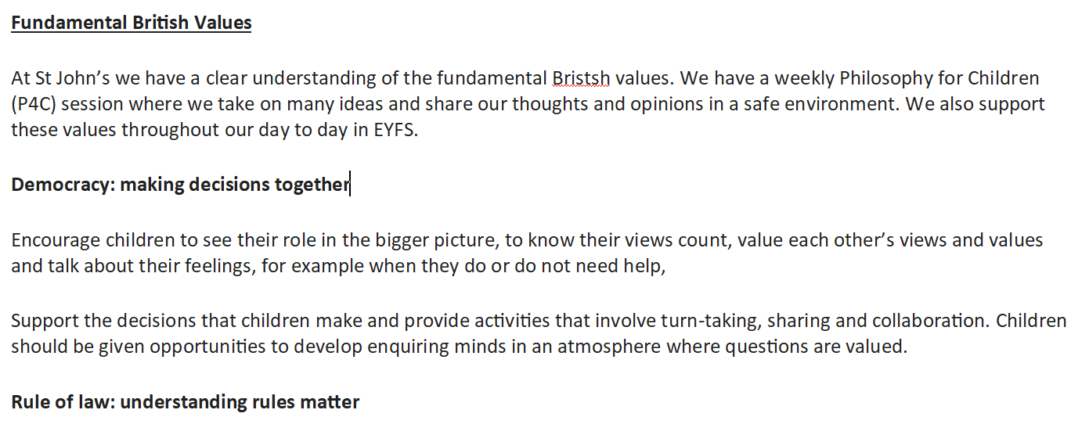

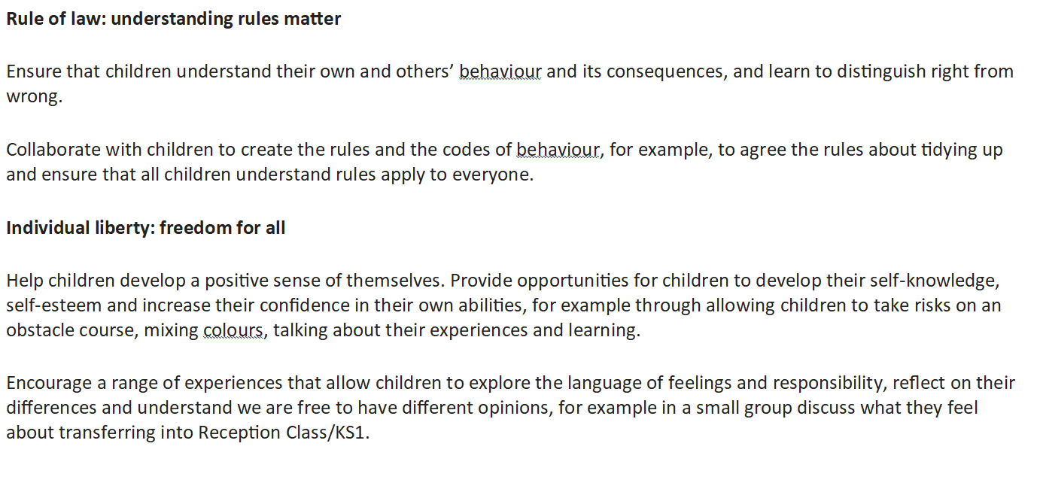

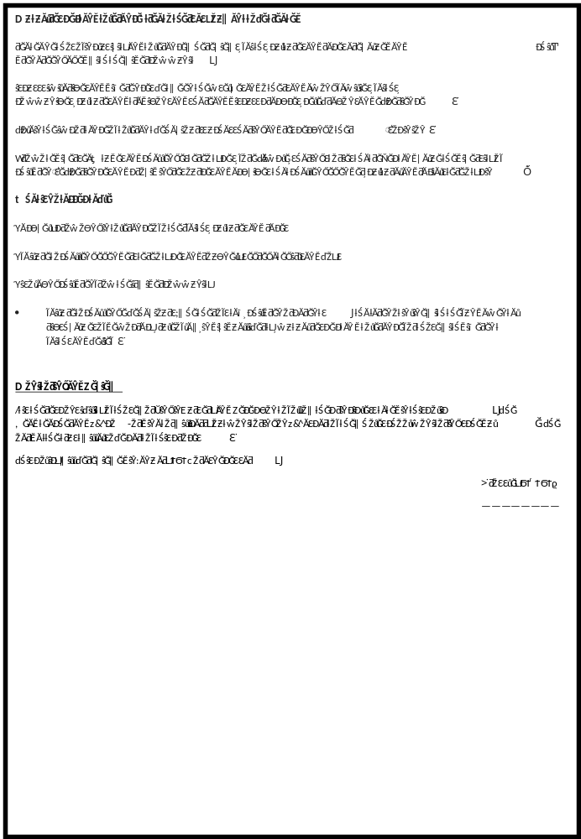

L Crossley
Sept 2026

