St John’s C.E
Primary School

EYFS Induction Pack

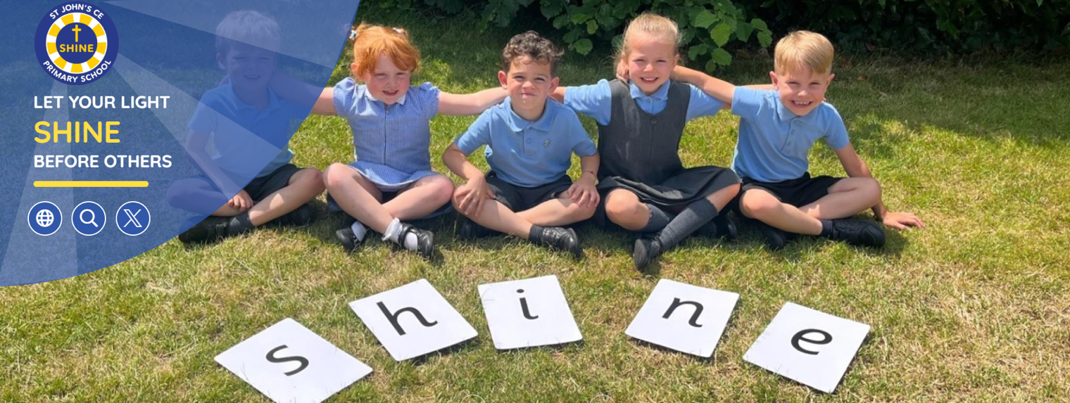






Headteacher’s Welcome

Dear Parents and Carers,

Welcome to St. John’s C.E Primary School. The Early Years and Primary Education you choose for your child is one of the most important decisions you will make. Thank you for choosing us.
A very warm welcome to you and your child as you join our school community. We are absolutely delighted that you are starting this exciting journey with us, and we look forward to getting to know you in the weeks and months ahead.
Starting nursery is such a special time – a moment filled with new beginnings, growing independence, and joyful discovery. We know that entrusting your child into someone else’s care is a big step, and we want to reassure you that we are fully committed to creating a warm, nurturing and stimulating environment where your child can thrive.

At our school, we place great value on building strong, trusting relationships – with the children in our care and with their families. We see parents as partners and believe that working together is key to helping children feel secure, confident and happy in their learning.

Our EYFS team is dedicated and full of enthusiasm. They are passionate about early years education and will take great care in helping your child settle, grow and develop a love for learning right from the very start.

Through play, exploration, and gentle guidance, your child will begin to make sense of the world around them, develop friendships, and build the foundations for a lifelong love of learning.

This induction pack contains key information to help you prepare for this important transition, and of course, we are always here if you have any questions or concerns. No question is ever too small – we’re here to support you every step of the way.

Thank you once again for choosing our school. We are so pleased to welcome you into our community and look forward to the wonderful journey ahead

Yours Sincerely,

Louise Bonter

Headteacher

Forward as One Trust 

St. John’s C.E Primary School is a proud member of Forward as One CE Multi Academy Trust. As a Church of England Multi Academy Trust, FA1 are a non-profit making educational charity with the charitable purpose to advance education for public benefit. FA1 therefore work closely with local authorities, maintained schools and other academy trusts to advance education for all.
The work of FA1 is rooted in the Christian values of service, justice, faith, grace and love. It is the experience that these values add value in any school – including schools without a Christian heritage – and so FA1 welcomes all schools, whatever their designation, to join the trust in their mission to improve educational outcomes for all.
As a Trust with a Church of England foundation, the following values are at the heart of all schools' work:

F | Family | Working together for collective success
O | Openness | Sharing with and being accountable to others
R | Resilience | Overcoming challenges through commitment and perseverance
W | Wisdom | Developing a life-long love for learning and understanding the world around us
A | Aspiration | Pursuing excellence in all that we do
R | Research | Grounding everything we do in evidence and best practice
D | Diversity | Fostering inclusive and vibrant learning communities


It is the aim of Forward as One for all children to become:
- Enthusiastic, life-long learners
- Resilient
- Critically reflective
- Hard workers
- Confident citizens
- Strong communicators
- Respectful
Forward as One strongly believe that every child should leave school with a deep enthusiasm for life and for learning.


Useful Contact Information

Our address is:

Email: info@stj.fa1.uk
Website: https://www.stjohns.oldham.sch.uk
X (Twitter): @StjFailsworth

St John's CofE Primary School
Ashton Road East
Failsworth
Manchester
M35 9PN
Tel: 0161 694 8096



Deputy Head Teacher

and Deputy Safeguarding Lead: Mrs L Rylands

Assistant Head teacher and Early Years Leader: Mrs L Crossley



Nursery Class Teacher: Miss E Earle Reception Teacher: Miss T Horrocks




EYFS Support Staff:
Miss L Harrison, Mrs S Potter, Mrs Speight



Pastoral Lead: Mrs C Wood SENCO: Miss R Penney

Welcome to Early Years - Nursery

St. John’s C.E Primary School Nursery is a term time provision that is integrated within St John’s C.E Primary School. Our 2-year-old and 3/ 4-year-old nursery provides high quality education and care in a fun and engaging environment where play is at the heart of what we do. The experienced and skilled staff in Nursery support children in their development in all areas of learning, as well as encouraging life skills.

Our nursery provision caters for both full and part-time places. Our setting provides excellent preparation for children’s next stage of education.

Opening hours are:

9:00am – 12noon
Or
9:00am – 3:15pm

Monday to Friday, term time only.

We recognise that all children come into our setting with varied experiences and all staff work hard to ensure that the learning opportunities provided widen their knowledge and understanding of the world, setting ambitious expectations for all children.

2-3-Year-Old Nursery (Little Stars)
Children can start nursery the term after their 2nd birthday if the place is government funded.

Nursery start dates are as follows:

- The first day school is open after 1st September.
- The first day school is open after 1st January.
- The first day school is open after 1st April.

If the place is not government funded, but the child is 2 years old, they can join immediately subject to available places. The fee is £9.50 per hour.

15 hours per week top up = £142.50
Days can be flexible.

Lunch per day = bring own lunch or the cost of a school meal

The Nursery is open term time only and closed all Bank Holidays.

Fees are payable either via Tax Free Childcare or by paying directly onto your child’s Arbor account. When reducing attendance or leaving the nursery 6 week’s written notice is required. Invoices must be settled before the due date so as not to affect the terms of your childcare. Please note that all invoices not settled within our payment terms may be referred to our Debt Recovery Agents, who will in turn retrieve it through the courts. We reserve the right to suspend or reallocate your place if payments are not made in a timely manner and therefore accruing unpaid fees. Your child’s nursery place will automatically be reallocated should 1 month’s unpaid fees accrue.

3-4 Year-Old Nursery (Sapphire Class)

The school hours are :

Monday to Friday 9:00am-12 noon
OR
Monday to Friday 9:00am- 3:15pm

Children can start Nursery the term after their 3rd birthday.

Nursery start dates are as follows:

- The first day school is open after 1st September.
- The first day school is open after 1st January.
- The first day school is open after 1st April.

If a child receives 15 hours but parent/ carer would like to top up to 30 hours but is not entitled to government funding, options are outlined below:

15 hours per week top up 12noon -3:15pm = £105 (£7 per hour)

We offer MORNINGS-ONLY sessions (15 hours funded) or FULL TIME. Mixed patterns of days/sessions are not available in our 3–4-Year-old Nursery e.g Monday all day, Tuesday morning and Wednesday all day.

School cannot admit a child if they are within a grace period from an eligibility code application made to a previous setting. School can only admit the child once the eligibility code has been revalidated.

The nursery is open term time only and closed all Bank Holidays.

Fees are payable either via Tax Free Childcare or by paying directly onto your child’s Arbor account. When reducing attendance or leaving the nursery 6 week’ written notice is required. Invoices must be settled before the due date so as not to affect the terms of your childcare. Please note that all invoices not settled within our payment terms may be referred to our Debt Recovery Agents, who will in turn retrieve it through the courts. We reserve the right to suspend or reallocate your place if payments are not made in a timely manner and therefore accruing unpaid fees. Your child’s nursery place will automatically be reallocated should 1 month’s unpaid fees accrue.

How do I apply?

- Collect an application form from the St John’s C.E Primary School office.
- Complete and return the application form, including any documentation required i.e.: Birth Certificate/ Passport/ Parent information and 30-hour eligibility code (if applicable)
- Once application is verified by school and eligibility details have been checked and confirmed, via the local authority funding portal, the office will contact you should we have places available.
- If a place is available for your child, you will be given a school induction pack to agree and sign, nursery fees contract, including Arbor payment setup (if required) and a start date for your child along with any other information needed for starting a new setting.

Collection of children

A child will not be allowed home with any person other that the one who normally collects her/him from nursery, unless prior notice is given by the parent. You must state on your Arbor form, all adults you consent to collecting your child. Children are also not permitted to be collected by a person under the age of 16.

Safeguarding

Please ensure our school records are up-to-date. We send text messages and emails as correspondence. It is vital we have the correct details. You may add or change details on Arbor directly.
Safeguarding is our upmost priority. We will only allow children to go home with somebody who is on the pick up form. If you need to add or change this form, please come into the school office or change it on Arbor. It CANNOT be done over the phone.

Holidays

We encourage regular attendance during term-time and any term time holidays will not be authorised. Nursery fees are still payable whilst a child is on holiday if this is within term time- this is to secure your child’s nursery place. We are unable to offer alternative days for the period your child is on holiday as our nursery is staffed based on the number of term-time children.

Sickness, Absence and Medication

Medication is only administered to children if prescribed by a doctor or health care professional. The medication must display a pharmacy label with the child’s full name, dosage and date or prescription. A school medication form must be completed and signed. Nursery fees are still payable if your child is sick or absent from nursery, this is to secure your child’s nursery place.

Are you Eligible for Government Funding?

If either yourself or your partner work 16 hours a week or more, then you could be eligible for 30 hours a week funding.
Parents need to log on to www.childcarechoices.gov.uk to check their own eligibility. If eligible a code will be supplied to you that the school needs to be informed of by completion of a Parent




Home School Agreement

St John’s C.E Primary School will:

• Provide a safe and happy environment for all children.
• Encourage children to always do their best.
• Provide a challenging and progressive curriculum to meet the needs of all children.
• Enable children to develop positive social relationships and high self-esteem.
• Promote high standards of work and help children to develop a sense of responsibility
• Encourage and enable children to make the right choices about their behaviour and help them to learn from mistakes that are made.
• Be open and welcoming, so parents can discuss any child informally at a mutually convenient time, and to report formally on your child’s progress each term.
• Offer opportunities for parents to be involved in the life of the school.
• Provide your child with extra-curricular opportunities that enrich our curriculum.

Parents and Carers will:
• Ensure that their child attends throughout each school term and arrive on time.
• Ensure that their child wears the correct school uniform (See website).
• Inform the school if their child is absent by telephone as soon as possible on first day of absence.
• Make the school aware of any concerns or changes in home circumstances that might affect the child’s learning or behaviour as soon as they know.
• Let school know of any changes to contact details (Phone numbers or addresses) as soon as possible.
• Attend parent conferencing about their child’s progress.
• Support their child’s understanding of the behaviour policy and support school in promoting high standards of behaviour and conduct.
• Always show respect for all members of the school community, Eg; staff, children and other parents, and be a role model to their children.
• Support the school’s approach to online safety and not upload or share any images, video or texts that could upset or offend any member of the school community.
• Support your child’s learning at school by monitoring children’s screen time at home (especially at bedtime)
• Ensure their children only have access to age-appropriate games and movies at home
• Ensure my child gets enough sleep before school.
• Keep school informed of any changes to a child’s medical information as soon as these are known.
• Support St John’s C.E Healthy School Policy and only send in water for your child to drink during the day, and healthy snacks (those low in sugar and salt) for break or lunch times.

St John’s C.E EYFS Pupils will:
• Come to school regularly and on time.
• Wear school uniform and be smart and tidy.
• Try their best
• Look after their school and surroundings
• Follow class agreements and school rules, doing their best to always show good behaviour and manners.
• Be a St John’s role-model to others.
- SHINE

Attendance

For your child to make progress in school it is extremely important that they are punctual, so they don’t miss the start of the day. Being 10 minutes late each morning results in one hour of school every week OR a full day each term.

We ask that you contact the school promptly on the first morning of every absence. If school isn’t informed or can’t contact you, our pastoral team may complete a home visit to check everything is ok. Please try to make every effort to arrange medical and dental appointments outside of school hours. We ask all parents for their full support in ensuring that holidays are not taken during term-time. There are a total of 175 non-school days every year to take holidays and to arrange other family visits and activities.

If your child is unwell, please call the school office on 0161 694 8096 option 1 before 9.00am.
A number of absence require a period of rest due to their infectious nature, in particular any upset tummies need to be absent for 48hrs following the last period of sickness and/or diarrhoea.
If your child becomes unwell during the day, we will contact a parent and ask that the child is taken home.

Nursery fees are still payable if your child is sick or absent from nursery, this is to secure your child’s nursery place.

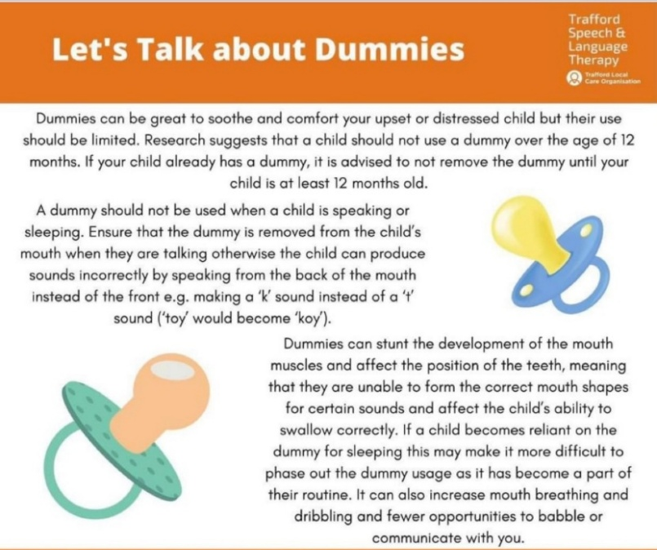
Missing Days Add Up!
Attendance | Number of Missed Days Per Year
98% | 4 days
96% | 8 days
90% | 19 days
85% | 29 days
80% | 38 days


Uniform (2YO, 3YO and 4-year-olds)

In St John’s EYFS Unit, we wear our uniform with immense pride to celebrate that we are a part of the St. John’s family.
Our expectations of school uniform are outlined below. Please ensure that all items are clearly labelled with your child’s name.
- Suitable coat- nothing too special as it will get sandy/ muddy!​
- Named wellies ​
- Spare clothes – please supply your own nappies and wipes
- Blue sweatshirt with school logo (or plain)​
- White polo shirt or white shirt ​
- Grey trousers, shorts or skirt ​(2 year olds can wear grey/ black leggings or joggers)
- Black school shoes ​
- White or black socks/ tights ​

- A small fleece blanket (if your child has daily naps)
- Hair tied back​
- No jewellery ​
- Please make sure every item is labelled with your child’s name​
You can purchase St. John’s School Uniform Here:
https://www.touchline-embroidery.com/shop-by-school/st-johns-ce-primary-school-failsworth
Nappies and Wipes

Nappies and wipes will need to be provided by the family. These will only be used for your child and staff will let you know when these need topping up.
Sleeping

We discourage part-time children from having a sleep while at Nursery. We will discuss full-time children sleeping on an individual basis. There are sleep safe mats provided and children will be supervised appropriately. This is the only time dummies will be permitted in school.
Snacks

Children will be offered snacks in the Little Stars room. Food such as cereal, crackers, breadsticks, toast, fruit. Please be advised that we have a NO NUTS POLICY in school.
Milk will be provided to 2-4 year olds each day.


School Lunches 

Miquill are currently the appointed supplier for St John’s C.E Primary School dinners and are determined to offer parents, carers and their children an excellent service, ensuring every child enjoys their meal and has the energy to study and learn in the afternoon.
If you would like your child to have school meals, you will need a ‘School Grid’ account. Please provide the school office with your email address to activate an account. You will then receive an email from Live Kitchen, our software providers, with all your necessary log in details. By accessing Live Kitchen online, you will be able to pre-order meals, view recipes, allergens, ingredients and make payments.
Whilst packed lunches welcomed, we encourage a school dinner. are Please DO NOT send any products into school which contain nuts e.g Nutella chocolate spread.


Can I bring sweets in for my child’s birthday?

Birthdays are an exciting time for children and we enjoy celebrating them in class. As a healthy school we ask that children do not bring sweets or cakes in for this special occasion. However, if you wish to bring in treats, a nice example may be a pencil, bubbles or a book for the class or celebration shelf in our school library.
Our Library

Children will visit our school library once a week. Children are allowed to borrow one book; unfortunately they cannot take another book until the previous book has been returned. If a book is lost or damaged, please speak to the class teacher or school office about a donation or replacement book.
P.E

Children in Nursery (3-4YO) and Reception will take part in a weekly P.E. session, in addition to their outdoor provision.
Please provide a full P.E. kit in a named drawstring bag. This will be kept in school and sent home at the end of each half term for washing.
P.E. kit should include:
- Black pumps
- White T-shirt
- Black or navy shorts


Before and After School Club

B&A Club is led by Miss Smith.
Email address: info@stj.fa1.uk

Foundation Stage Curriculum

At St John’s we aim to provide pupils with high quality teaching and learning, so that they can become effective life-long learners, striving for excellence, starting within the foundations set in Nursery and Reception. Our ambitious curriculum is designed to give all children the knowledge, self-belief and cultural capital they need to succeed in life.
To develop independent learners and school readiness our curriculum focuses heavily on the prime areas of learning throughout Autumn term, for example there is a strong focus on the development of speech and language skills, routines and expectation, sharing and social skills. Children in Reception begin Read, Write, Inc, our focused phonics scheme, on entry whilst 3-4 Nursery begin to access RWI from summer term to give them the very best opportunity to strive and set them up ready for Reception and future learning. Before this point children will be tuning into sounds and getting ready for RWI throughout our St John’s curriculum.
We aim to demonstrate clear Christian characteristics and values, whilst at the same time, encouraging recognition of and respect for other faiths.
Our school value of “Growing together to shine in God’s World” underpins all that we do at St. John’s. We believe in each and every child and celebrate our one family in all that we do.
“Growing together to shine in God’s World”

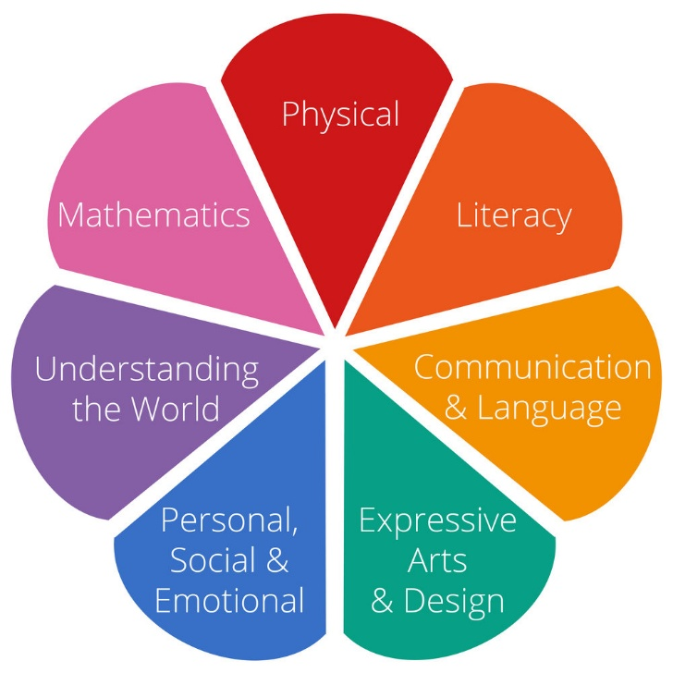


Data Collection for Arbor

Identity
Surname
Forename
Gender
Date of Birth (day/month/year)
Country of Birth
Country of Origin
Date of Entry to the UK (if applicable)
Ethnicity
Nationality
Languages Spoken
Religion
Pupil Home Address and Postcode

Family Contact Details – Priority Contact 1
Full Name
Relationship to Pupil
Address and Postcode
Phone Numbers
Email

Family Contact Details – Priority Contact 2
Full Name
Relationship to Pupil
Address and Postcode
Phone Numbers
Email

Family Contact Details – Additional Contact
Full Name
Relationship to Pupil
Address and Postcode
Phone Numbers
Email

Siblings at St John’s
Do you have other children at St John’s? | Yes | No
If yes, please write their names and year groups below
Name and Year Group:
Name and Year Group:
Name and Year Group:
Siblings at any other schools?

Educational Needs
First Language (Native Language)
Does this child understand English?
Does this child speak English?
Is English spoken at home?
Does this child have special educational needs or any disability?

If yes, please give details
Does this child have an Education Healthcare plan? | Yes | No
Is this child eligible for free school meals? | Yes | No
Is this child in receipt of EYPP?  (Early years Pupil Premium) | Yes | No
Is this child in receipt of PPG?  (Pupil Premium Grant funding) | Yes | No
Traveller Status  Circle the box that applies | No traveller status | Gypsy/Roma (housed)
Traveller Status  Circle the box that applies | Occupational traveller | Gypsy/Roma (travelling)
Traveller Status  Circle the box that applies | Traveller (other)
Is this child a Service Child?  One or both parents in armed forces | Yes | No
Is this child a ‘Looked After Child’?  A child in care | Yes | No

Parental Responsibility
Please name all people with Parental Responsibility for your child and give their date of birth below. ie who is named on their birth certificate (birth certificate will need to be seen for Nursery and Reception children)
Full name of person with parental responsibility
Date of birth
Full name of person with parental responsibility
Date of birth

Name and address of family doctor
Name of Health Visitor
Current childcare arrangements
(home with parent/relative/
playgroup/private nursery/
childminder)
Are there any other professionals working with your child?
Eg. Speech therapist/physiotherapist/ Early Help/ Social services etc.

Nursery Extended 30 hours free childcare (working parents)
Nursery children aged 2, 3- and 4-year-olds from working families may be entitled to an additional 15 hours per week (extended or 30 hours entitlement). This is for 38 weeks of the year.

If you have a valid eligibility code, this will need to be checked by school on the LA Provider Portal, to confirm relevant eligibility start and end dates prior to commencing the extended hours.
30 Hour Eligibility Code:

Signed:
Date:

Medical Form | 

Child’s Information
Full name of child
Gender
Date of Birth (day/month/year)

Contact Details
Home phone number
Mobile phone number
Email address

Medical Needs
Does your child have any medical needs?  Please circle all that apply | Speech | Asthma
 | Sight | Hearing
 | Allergies | Eczema
 | Dietary Requirements | Other
If yes, please give brief details:

Medical Professionals
Are there any other people involved in supporting your child’s health?  Please circle all that apply | Orthoptist | Social Worker
 | Speech Therapist | Paediatrician
 | Physiotherapist | Portage Worker
 | Other
If yes, please give brief details:
Name, address, phone number

Health Care Plan
Does your child have a Healthcare Plan, or in the process of being assessed? | Yes | No
If yes, please give brief details
Brief overview and name of educational psychologist involved

Children’s Services
Is your child known to Children’s Services? | Yes | No
If yes, please give brief details
Eg. Common Assessment Form (CAF), Team around the Child, Child Protection

Signed:
Date:

Early Years Pupil Premium (EYPP) and Disability Access Fund (DAF)

St John’s can access extra money to support children whose parents meet the EYPP criteria, allowing these children to qualify for an addition 53p per hour which is an additional £302.10 per year. Even if you are unsure, please fill in the form and then we can check for you.

All your details will be stored confidentially and only used to apply to Oldham LA for EYPP or DAF.

The EYPP Criteria:

If your child meets 1 or more of these criteria, then we can claim extra money for your child:

• Their family gets 1 of the following:
o Income Support
o Income-based Jobseeker’s Allowance
o income-related Employment and Support Allowance
o support under part VI of the Immigration and Asylum Act 1999
o the guaranteed element of State Pension Credit
o Child Tax Credit (provided they’re not also entitled to Working Tax Credit and have an annual gross income of no more than £16,190)
o Working Tax Credit run-on, which is paid for 4 weeks after they stop qualifying for
Working Tax Credit
o Universal Credit and have a household earning less than £7,400

• they are currently being looked after by a Local Authority in England or Wales
• they have left care in England or Wales through:
o an adoption
o a special guardianship order
o a child arrangement order

Disability Access Fund
If your child is 3 or 4, is receiving child Disability Living Allowance and is receiving the free entitlement, he or she is eligible for the Disability Access Fund (DAF).A one-off payment of £938 DAF is paid to your child’s early year’s provider. The purpose of DAF is to support providers to make reasonable adjustments and build the capacity of their setting to support children with disabilities.
Is your child eligible for and in receipt of Disability Living Allowance (DLA)? | Yes | No

Child Information
Full name of child
Date of Birth (day/month/year)
Home Address and Postcode

Parent 1 Information
Name of parent
Date of Birth (day/month/year)
Parent’s National Insurance number
NASS number
If you are an asylum seeker, we need the 9-digit NASS number as
issued by the Home Office

Parent 2 Information
Name of parent
Date of Birth (day/month/year)
Parent’s National Insurance number
NASS number
If you are an asylum seeker, we need the 9-digit NASS number as
issued by the Home Office

Signed:
Date:

Parental Consents

Child Information
Full name of child

I give permission for my child…
To be on a photograph or video to be used or displayed within the school premises, school publications, Seesaw, school website, newspaper, X or other public forums | Yes | No
To take part in offsite school visits/trips/activities requiring walking/and or travel by coach, public transport or taxi, all supervised by school staff. | Yes | No
To receive first aid or urgent medical treatment in an emergency from on-site first aider. | Yes | No
To taste food during food cooking/tasting lessons.  Please specify if your child has any allergies. | Yes | No
To view a video or clip of a Parental Guidance (PG) film in school. | Yes | No
To be a part of the Seesaw online learning platform (EYFS / KS1) | Yes | No
Use the internet, whilst being supervised, and follow the safe usage agreement . | Yes | No

Signed:
Date:

Home-School Learning Platform - Seesaw

Seesaw is a secure, online learning platform for pupil/parent engagement and allows the class teachers and school to share learning and messages throughout the school day. You must download the Seesaw family app and login with the QR provided by school. When there are new posts or messages, you'll be notified and can see what's new. Seesaw journals are private and only accessible by staff and parents.
By giving consent, you will see posts created by your child, or other children who are tagged in the post. If you do not want your child tagged into whole class photographs please let us know on the consent slip.

You can read more about their strong privacy promises here: https://web.seesaw.me/privacy
For more information on GDPR, please visit https://ec.europa.eu/info/law/law-topic/dataprotection/reform/rights-citizens

When signing up to Seesaw we ask Parents/ Carers to agree to the following guidelines:
As a parent/carer I will…
• Not publish any of my child’s observations, photographs or videos on any social media site
• Understand that my child’s image may be used in another child’s profile if they are engaged in the same activity. This image will not be shared by the other parent (please see above point)
• Keep the login details within my trusted family
• Speak to a member of staff if I experience any difficulties accessing my child’s learning journey



End of School Day Arrangements

Collecting your child at the end of the school day
Children will be dismissed at 12noon or 3:15pm as follows:

When collecting your children, please avoid crowding by stepping back, onto the playground and away from the entrances to allow us to dismiss children safely and quickly.

Please complete the table attached and return to school.

Child Information
Full name of child

People that can collect
I give permission for the following people to collect my child from school
Please write names in this box

Name | Phone Number | Relationship to Child

Signed:
Date:

Acceptable Behaviour Policy for Parents and Carers

We use the term ‘parents’ to refer to:
- Anyone with parental responsibility for a pupil
- Anyone caring for a child (such as grandparents, child-minders, foster carers)

Our school strives to work in partnership with all the families who allow us to care for and educate children. We ask that each parent/carer uphold the agreement to show our shared commitment to your child’s education and to ensure we maintain a safe and protective environment in which to learn and work.

As St John Primary School is a values-led, Rights Respecting School. We believe that our vision relies on the school being able to establish whole school cultures that promote mutual respect amongst us all, make us feel safe and induces a lifelong love of learning for children and adults to be inspired and challenged in order for them to excel.

We believe that our Acceptable Behaviour Policy is integral to this, with an ethos that under pins the values within this school enabling all members of the school community to fulfil its vision, to ensure the wellbeing of us all and create responsible citizens of the future.

At St John’s we believe it’s important to:
- Work in partnership with parents to support each child’s learning
- Create a safe, respectful, and inclusive environment for pupils, staff and parents
- Model appropriate behaviour for our pupils, always
- Reflect our school’s values and all children and adults to excel in everything they do.
- Treat all members of the school community with respect

To help us achieve this, we set clear expectations and guidelines on behaviour for all members of our school community. This includes staff (through the staff code of conduct) and pupils (through our behaviour policy).

The Acceptable Behaviour Policy for Parents aims to help the school work together with parents by setting guidelines on appropriate behaviour by ensuring that:
- That adults always set a good example to children, showing them how to get along with all members of the school and the wider community.
- That no members of staff, parents or children are the victims of abusive behaviour or open to
threats from other adults on the school premises.
- Physical attacks and threatening behaviour, abusive or insulting language verbal or written, to
staff, governors, parents and carers, children and other users of the school premises will be dealt with
- Behaviour that will not be tolerated

This is not an exhaustive list but seeks to provide illustrations of such behaviour:
- Disrupting, or threatening to disrupt, school operations (including events on the school grounds and sports team matches).
- Intimidating a member of staff or member of the school community either in person or over the phone e.g.: standing very close to the person/ slapping, punching, or kicking/ shouting/ speaking in an aggressive/threatening tone/ the use of aggressive hand gestures/exaggerated movements.
- Swearing, or using offensive language.
- Sending abusive messages to another member of the school community, including via text, email or social media or inappropriate posting on social networking sites which could bring the school into disrepute or be deemed as bullying e.g.: posting defamatory, offensive or derogatory comments about the school, its staff or any member of its community.
- Smoking or drinking alcohol on the school premises or possessing or taking drugs.
- Breaking the school’s security procedures, including risk assessments or conduct/ health and safety legislation.
- Racist or sexist comments including sexual innuendo, including any derogatory comments made about the protected characteristics: age, gender, sex, sexual orientation, gender reassignment, race, religion and belief, marriage or civil partnership, pregnancy, or maternity.

Inappropriate use of social media
Social media websites are being used increasingly to fuel campaigns and complaints against schools, headteachers, school staff, and in some cases, other parents/pupils. St John’s C.E Primary School considers the use of social media websites being used in this way as unacceptable and not in the best interests of the children or the whole school community. Any concerns you may have, must be made through the appropriate channels by:
- Speaking to the Class teacher
- Speaking to the Key Stage Leader/ Pastoral Lead
- Speaking to the Assistant Headteacher/Deputy Headteacher
- Speaking to the Headteacher

Following the appropriate channels ensure that any complaint is dealt with fairly, appropriately, and effectively for all concerned. If any pupil or parent/carer of a child/ren being educated at St John’s C.E Primary School is found to be posting libellous or defamatory comments on Facebook or other social network sites, they will be reported to the appropriate 'report abuse' section of the network site.

All social network sites have clear rules about the content which can be posted on the site, and they provide robust mechanisms to report contact or activity which breaches this. The school will also expect that any parent/carer or pupil removes such comments immediately. In serious cases the school will also consider its legal options to deal with any such misuse of social networking and other sites. Additionally, and perhaps more importantly, is the issue of cyber bullying and the use by one child or a parent to publicly humiliate another by inappropriate social network entry. We will take and deal with this as a serious incident of school bullying.

Persons Causing Nuisance / Disturbance on School Premises Section 547 of the Education Act 1996
School premises are private property, and parents have been granted permission from the school to be on school premises. However, in case of abuse or threats to staff, pupils or other parents, school may ban parents from entering school. It is also an offence under section 547 of the Education Act 1996 for any person (including a parent) to cause a nuisance or disturbance on school premises. The Police may be called to assist in removing the person concerned. School is not responsible for organising arrangements for children in the above circumstances. Parents will need to provide alternative arrangements for bringing children into school.

Breaching the Acceptable Behaviour Policy
If the school suspects, or becomes aware, that a parent has breached the Acceptable Behaviour Policy, the school will gather information from those involved and speak to the parent about the incident.
Depending on the nature of the incident, the school may then:
- Send a warning letter to the parent/ make a telephone call directly to the parent
- Invite the parent into school to meet with a senior member of staff or the Principal
- Contact the appropriate authorities (in cases of criminal behaviour)
- Seek advice from the school’s legal team regarding further action (in cases of conduct that may be libellous or slanderous)
- Ban the parent from the school site

The school will always respond to an incident in a proportional way. The final decision for how to respond to breaches of the Acceptable Behaviour Policy rests with the Headteacher. The Headteacher will always consult the chair of governors and the Trust CEO, before banning a parent from the school site.

Unacceptable behaviour will result in Oldham Council and the Police being informed of the incident.

Whilst every effort will be made to work with parents, this will only be possible where parents behave in an acceptable way. Unfortunately, where a parent’s behaviour is either unacceptable or serious it will not be possible to continue working with him/her and, as a final resort, legal action may be taken.

Children learn best when there is a positive partnership between home and school.

Please sign and date below to show you agree to fully comply with school’s acceptable Behaviour Policy.

Name:
Signed:
Date:

Intimate Care | 

As your child is in Early Years, please complete the consent form below for school to provide intimate care if needed.

permission for school to provide intimate care
Name of child
Date of birth
Name of parent/carer
I give permission for the school to provide appropriate intimate care to my child (e.g., changing soiled clothing, washing and toileting) |  | □
I will advise the school of anything that may affect my child’s personal care (e.g., if medication changes or if my child has an infection) |  | □
I understand that all care will be carried out in a respectful, safe, and hygienic manner, in line with the school’s policies and procedures. |  | □
I will provide the school with a bag containing all necessary items, such as nappies, wipes, and a change of clothes, for use with my child. I understand that it is my responsibility to ensure these items are kept stocked and up to date. |  | □
I do not give consent for my child to be given intimate care (e.g., to be washed and changed if they have a toileting accident).  Instead, the school will contact me, or my emergency contact and I will organise for my child to be given intimate care (e.g. be washed and changed).  I understand that if the school cannot reach me or my emergency contact if my child needs urgent intimate care, staff will need to provide this for my child, following the school’s intimate care policy, to make them comfortable and remove barriers to learning. |  | □
Parent/carer signature

